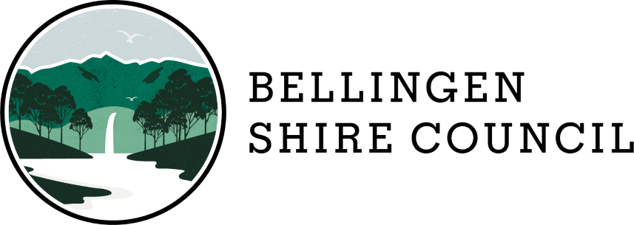

COMMUNITY SUPPORT FUND – FINAL PROJECT REPORT

APPLICANT: _____________________________________________________

PROJECT NAME: _____________________________________________________

PROJECT DATE(S): _____________________________________________________

GRANT AMOUNT $: _________________________________________ (GST inclusive)

The completion and return of this report is a requirement of your funding agreement with Bellingen Shire Council. This report provides valuable information that enables Bellingen Shire Council to continue to assist community and not-for-profit organisations and to undertake ongoing assessment of the Fund and recognition of the value of the Community Grants Program.

Acquittal reports must be completed and returned to Bellingen Shire Council within two months of the project/activity taking place. Failure to provide an acquittal report may result in any future requests for support being refused or deemed ineligible.

We strongly suggest that you keep a copy of all applications and reports for your own records.

Please return the completed and signed report to the Community Development Officer via email at louisefazio@bellinge.nsw.gov.au and Cc council@bellingen.nsw.gov.au.

PROJECT REPORT

Project Description
Please provide a brief description of your project/activity e.g.; where, when, how many attendees, what activities took place, etc.

Objectives and Outcomes
Please describe how your project/activity met its objectives as outlined in your application. What were the outcomes and how did you achieve these outcomes?

Alignment
Please list and describe how your project/activity aligned to Council’s priorities as outlined in its Community Vision.

Acknowledgment
How was Bellingen Shire Council acknowledged as part of this activity/project?

Grant Expenditure
Please provide details on how the Community Support Fund grant funds were used. Please provide a budget breakdown including copies of invoices/receipts. This can be provided as an attachment.

Project/Activity Success
Please describe how successful your project/activity was including any key learnings and outcomes.

Additional Information
Please provide any additional information regarding your project/activity including photos, media clippings, etc (up to a maximum of 5mb). Please note: Council may use this information in its reports and/or for promotional purposes. By providing photos, Council is of the understanding that the appropriate approvals have been given by any person or persons pictured.

General Comments/Feedback (optional)
Please provide any additional comments or feedback regarding your project/activity or the Community Support Fund.

I certify that the information contained in this report is true and accurate.

Name:

Signature:

Position: Date:

I hereby give permission for Bellingen Shire Council to use the information contained in this acquittal report for evaluation / reporting / promotional purposes:

q Yes q No

